

1. **INTRODUCTION**
   1. **Overview**

ProjectReportTemplate

**A brief description about your project**

Here I have developed a project on Tour and Travel. Online Tour and Travel Booking is a system that gives you the facility of booking any type of packages (Summer special packages, Manali tour packages, Shimla special packages, adventures etc). This system is made, so that customer can easily book ticket for all packages of tourist places such as hills,trekking, adventures, spirituals and user can also register for hotels for different types of room. The project ‘Tours and Travels’ is developed to replace the currently existing system, which helps in keeping records of the customer,details of destination as well as payment received. Payment gateway is also available in this site.

* 1. **Purpose**

**Use of this project this. What can the be archieved using this.**

* Overall improved fitness: One of the major benefits of trekking is that it improves your physical health immensely
* Reduces Stress
* Improves Cardiovascular strength
* Social benefits
* Softer skill development:
* Cultural Understanding
* Inner Cleanse

1. **Problem Definition & Design Thinking**
   1. **Empathy map screenshot**

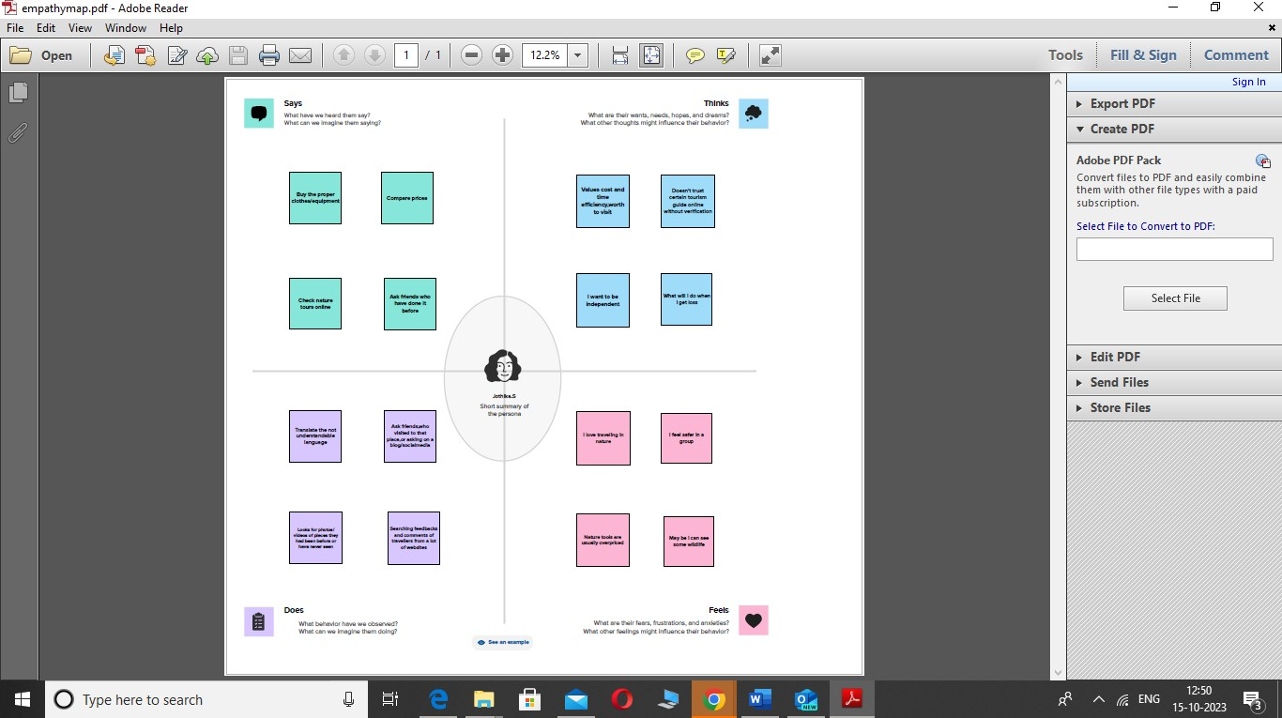

* 1. **Ideation & Brainstorm map screenshot**

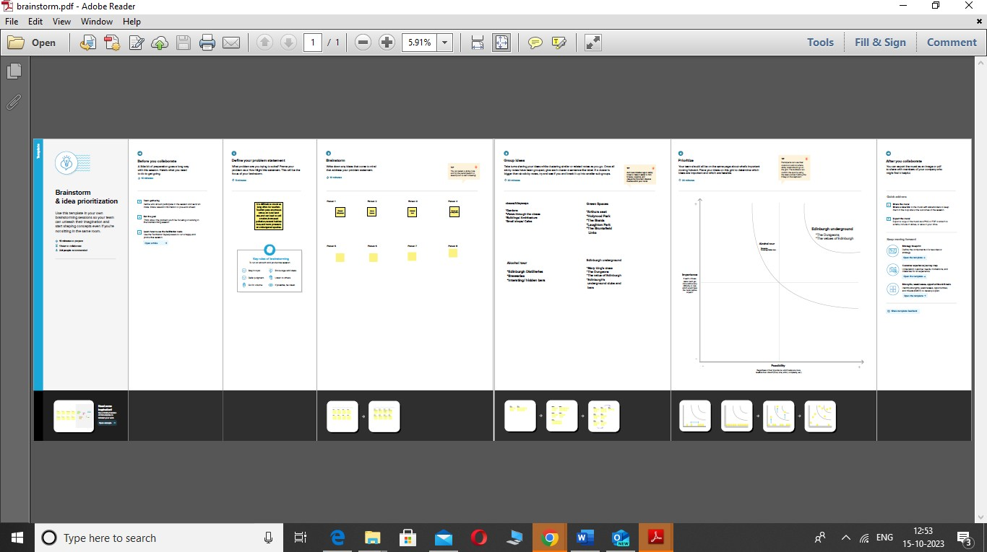

1. **RESULT**
2. **GST reports**:

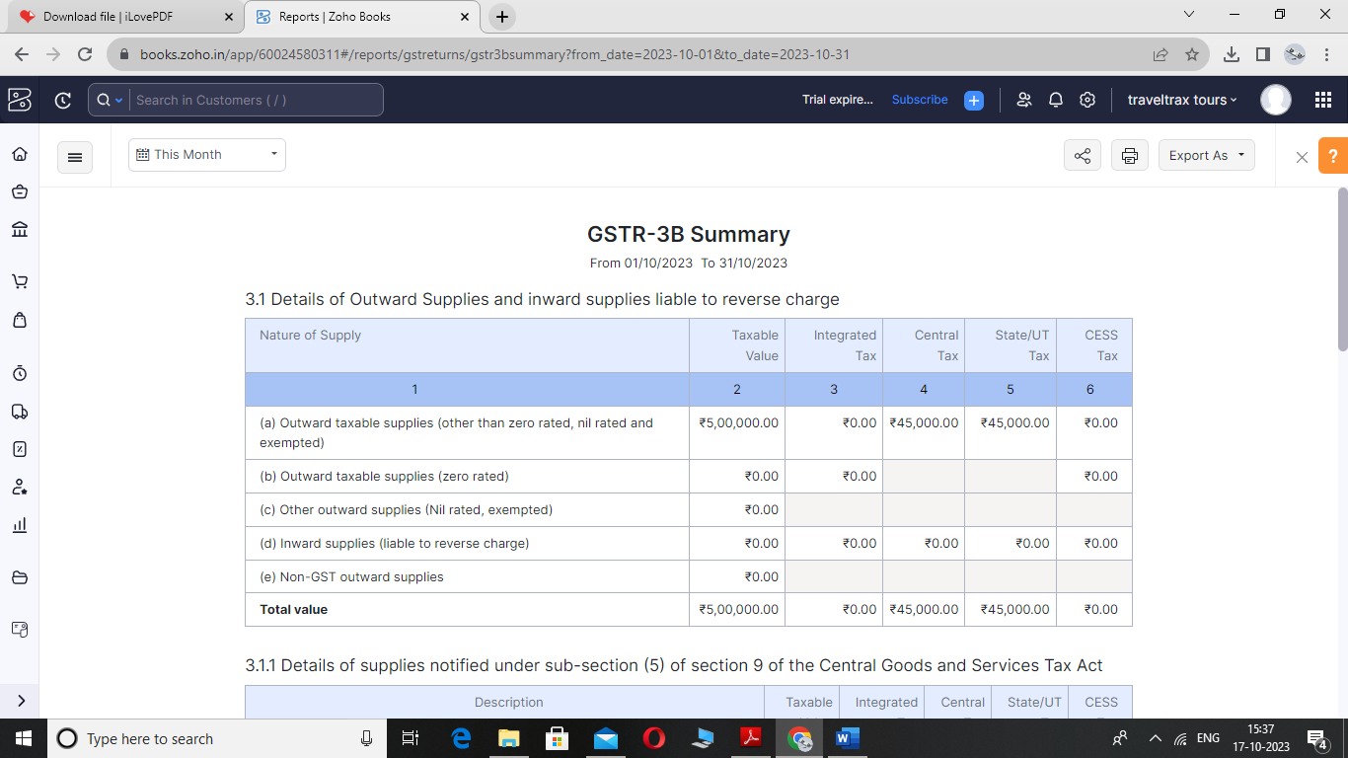

1. **Aging Receviable Summary**

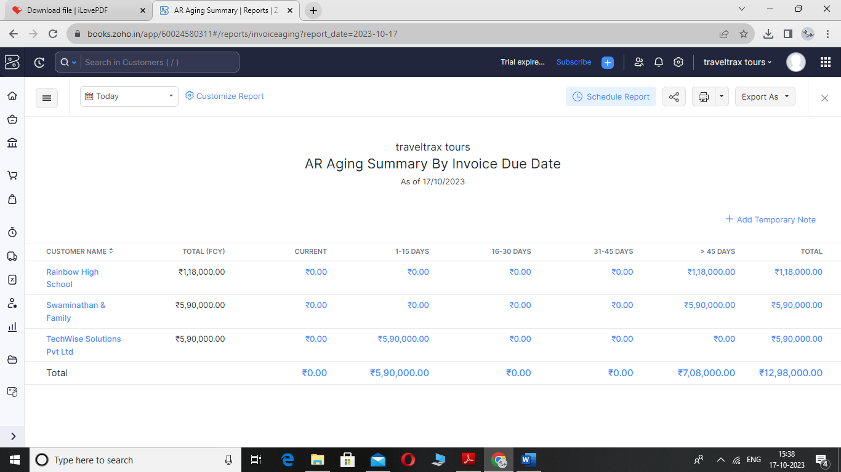

1. **Aging payable summary**

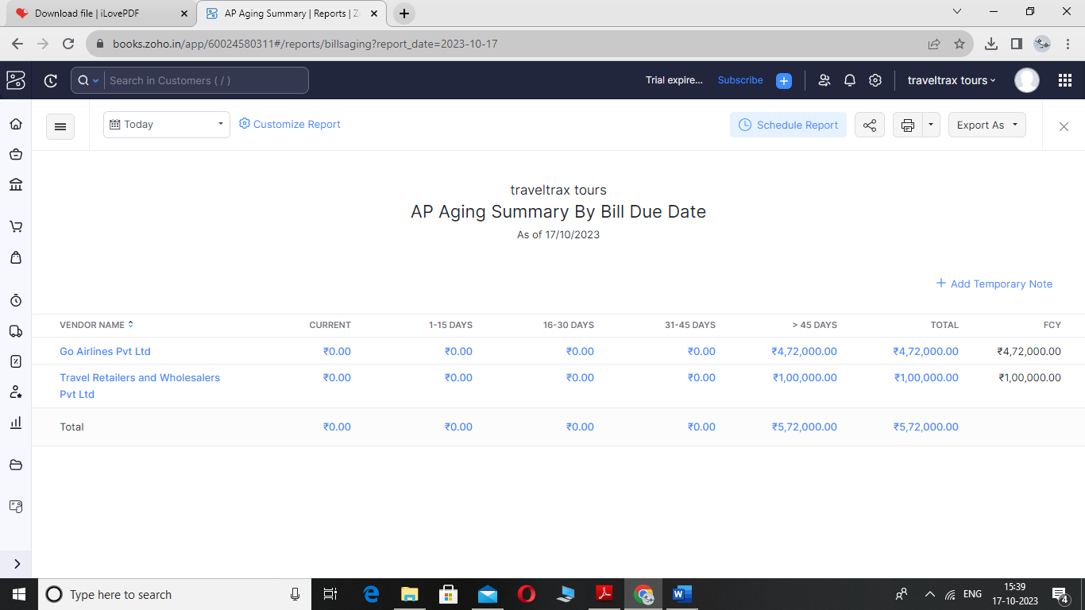

1. **Items**

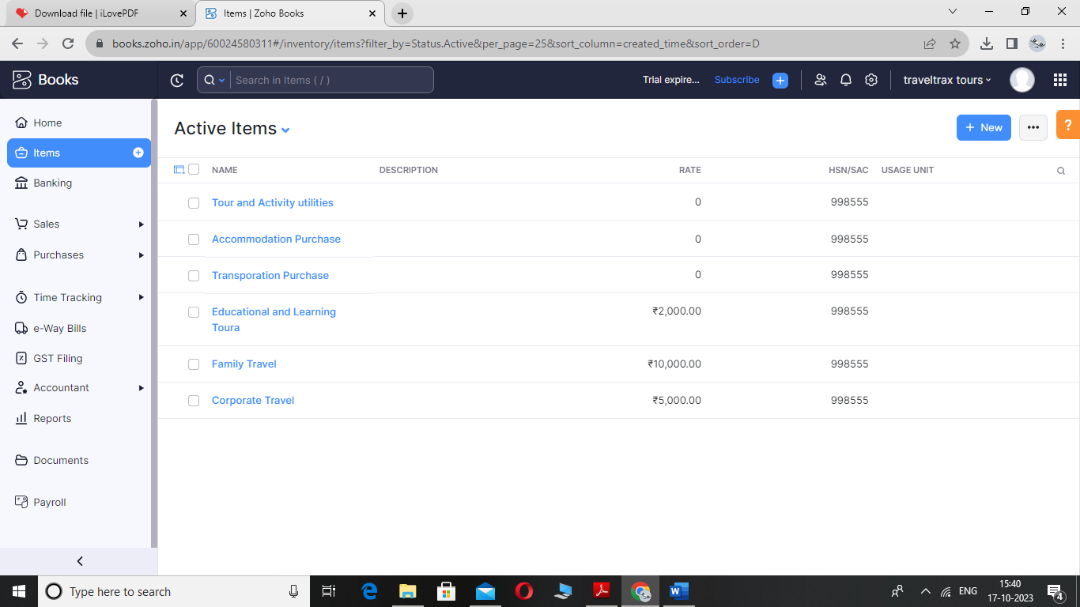

1. **Sales Invoice:**

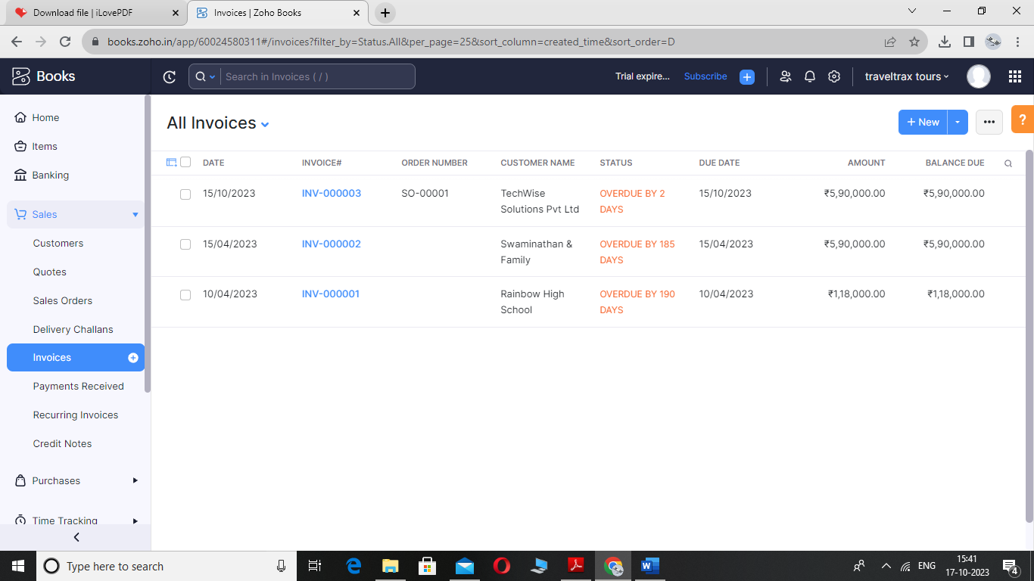

1. **Purchase Bills**

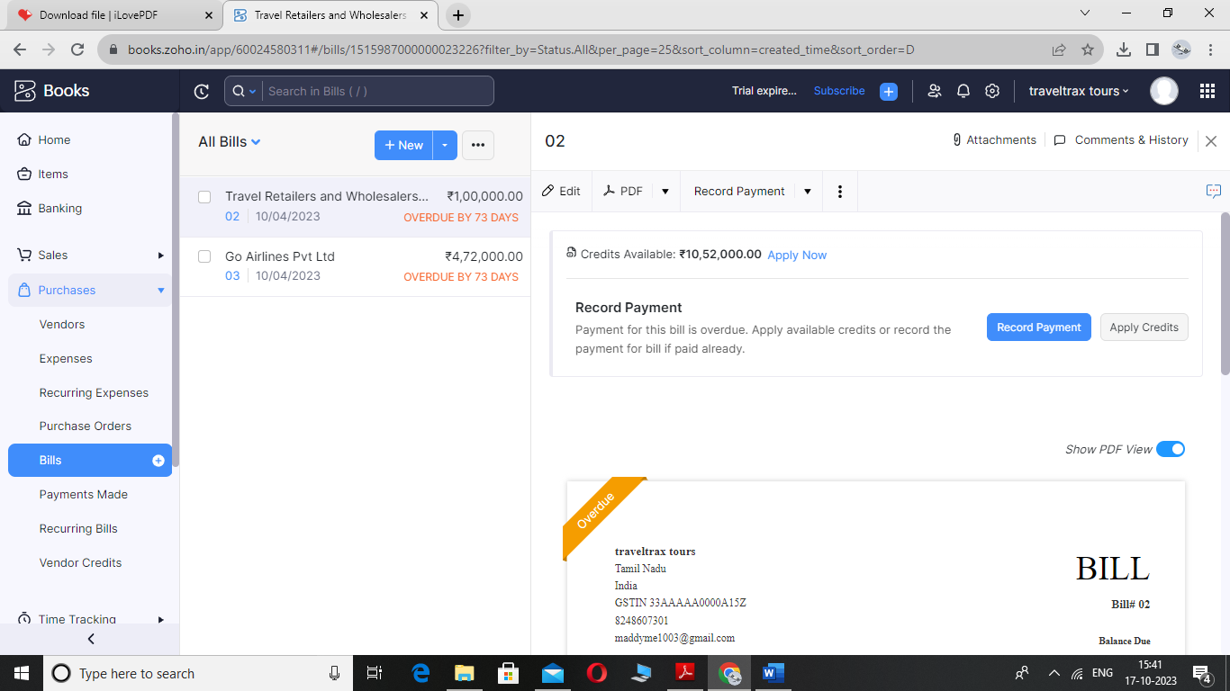

1. **Customers**

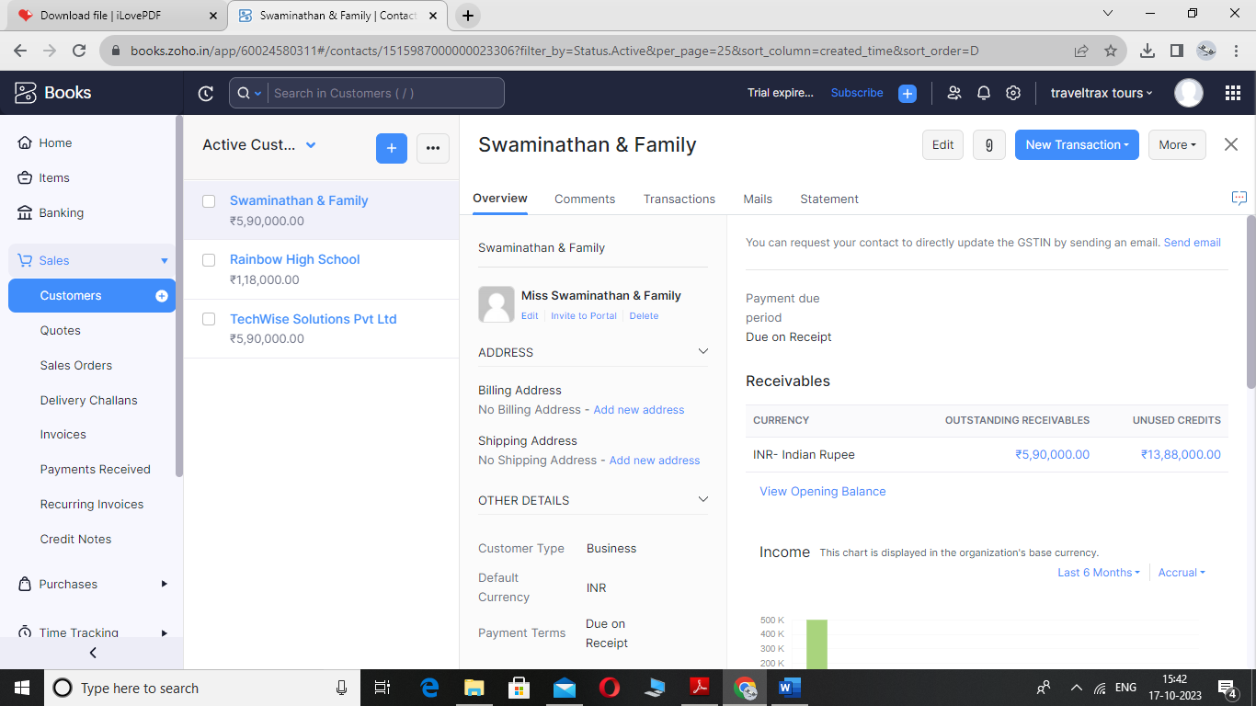

1. **Vendor**

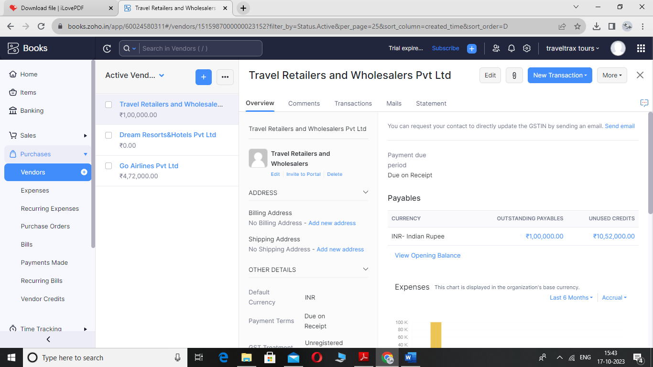

1. **Banking**

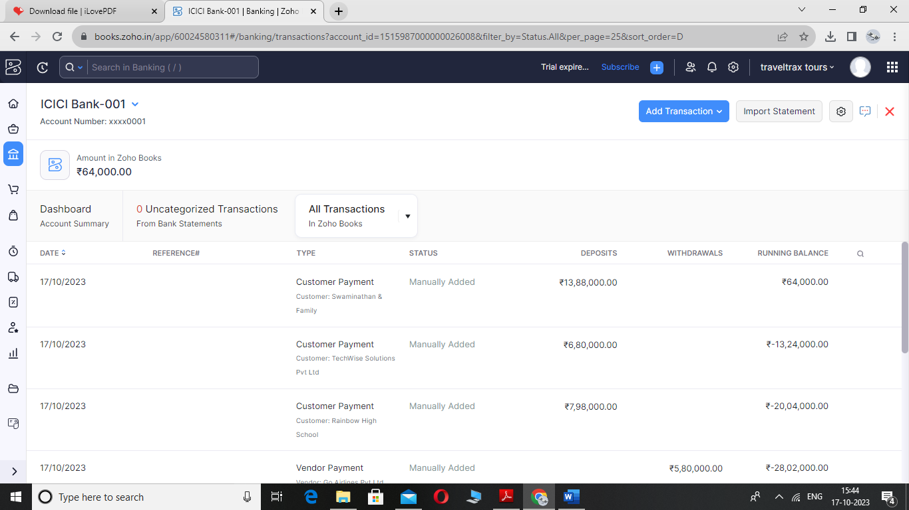

1. **ADVANTAGES & DISADVANTAGES Advantages:**

A typical tour package will usually include plenty of destinations. Chances are that going to all these places on your own would cost a lot more, mainly because travel agents and tourism companies have good connections with the hotels and transportation companies, and also because they get maximum discounts for sending groups rather than individuals or single families.

One of the biggest advantages is of course the convenience. As earlier suggested, planning for a full- fledged trip and visiting various places will take quite a lot of planning and due diligence. But when you opt for a tour package, you can just sit back and relax — at least as far as planning is concerned.

You will be able to relax and enjoy your travel and the places without having to worry about the tickets, and hotel reservations in your next stop.

Tour packages can be a great option when you are looking to plan a honeymoon or travel with your family. A poorly planned trip can be quite embarrassing as well as stressful; therefore, going with a reputable travel company might be a safer option and experiment.

**Disadvantages:**

The biggest disadvantage of a tour package is the lack of control. You need to follow the guidelines and a strict schedule. You cannot extend your stay in a certain place even if you love it. Similarly you cannot move to the next place if there’s nothing to be excited about, before the scheduled time.

You need to be extra careful while choosing one of these packages. The aforementioned advantages can easily turn into disadvantages if you don’t choose the right company.

You will have to be a little flexible with your dates and timings, in case you are looking to leave and arrive back on certain dates. You might find it hard to find an appropriate trip with frame.

1. **APPLICATIONS**

**The areas where this solution can be applied**

As highlighted, NFC technology is the leading form of technological innovation in the tourism sector. It can be used to provide visitors with key information and to personalize their customer journey. Traditionally, if a guest needed to know about local attractions or good places to eat nearby, they would have to wait to talk to the hotel concierge. However, many hotels now use NFC technology to their advantage to make it easier for visitors to get the information they need instantly. If you’re interested in learning more about the possibilities that are available to you, helps businesses implement NFC technology in innovative ways to create fun and unique experiences. With our platform, companies can broadcast text, visual, video and 3D content. They can create self-guided tours for museums, art galleries, historical sites, parks, resorts and much more.

1. **CONCLUSION**

Conclusion summarizing the entire work and findings.

**Profit & loss Report**

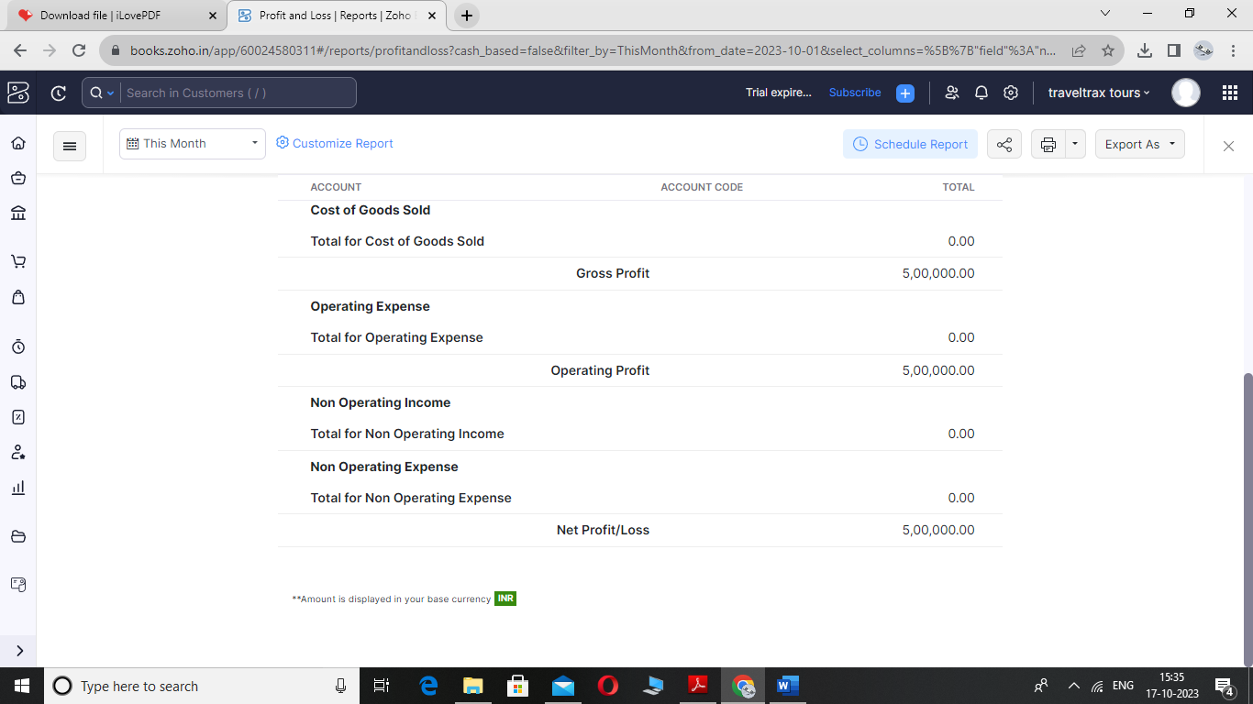

**Balance sheet Report**

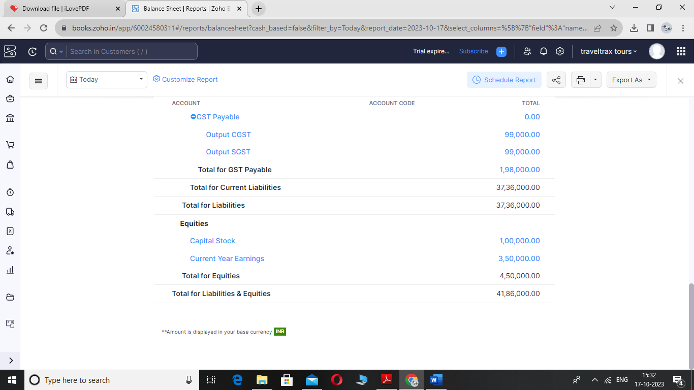

1. **FUTURE SCOPE**

**Enhancements that can be made in the future.**

New travel formats like eco-tourism, solo travel, e-tourism, micro-adventures, and life-long travel are emerging to meet increasingly fragmented and personalised needs. Players in the industry continue to push the boundaries by exploring new relationships with time, space, and purpose.

According to Evolve's 2022 travel forecasts, the average trip will likely be longer in length (5-7 nights in 2022, compared to an average of 3.8 nights in both 2020 and 2021). Longer trips will be increasing in demand as a result of the many work-from-home opportunities too

Revenue in the Travel & Tourism market is projected to reach US$18.91bn in 2023. Revenue is expected to show an annual growth rate (CAGR 2023-2027) of 13.47%, resulting in a projected market volume of US$31.35bn by 2027.

The influx of international tourists in India is projected to reach 30.5 million by 2028. The statistics are a reflection of the booming growth and potential of the hospitality sector in India that is rising after the lull created by the pandemic.

1. **APPENDIX**

**A Source Code Attach the code for the solution built**

* Zoho Books is your one-stop platform for managing your accounting tasks and organizing your transactions.
* It's a single secure location to keep up with your company's bills and invoices, reconcile your bank statements, control your spending, oversee projects, and eliminate GST compliance worries
* **Usability:** Zoho Books' clean and simple dashboard gives you immediate, convenient insight into your financial health. An effective, user-friendly UI makes Zoho Books easy to navigate.
* **Security:** Zoho Books protects your privacy and security with IP restrictions, two-factor authentication, SSL, and more. Your data can only be accessed by the users that you authorize.
* Learn more about Zoho's privacy and security policy.
* Zoho Books is built with dependable features that protect your data and produce accurate results for your accounting. Rely on Zoho Extensibility: Zoho Books is designed to help your business connect across multiple platforms.
* Extend your accounting with a library of more than 300 business apps via Zapier, or take advantage of built-in connections with other apps in the Zoho suite.
* ReliabilityBooks customer support team to assist you in making the best use of Zoho Books